**Design Engineering**

**COMPENENT LEVEL DESIGN:**

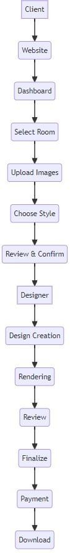



**ARCHITECTURAL DESIGN**